Dear Parents / Carers,

Welcome back to Term 2! I hope everyone had an enjoyable, restful and safe holiday. We are all looking forward to an exciting and productive term ahead. Last Friday we farewelled Miss Lina Younes. She is due to have her baby in a few weeks and will be taking leave for the remainder of the year. I am sure you will agree that she will be greatly missed. Starting Term 2 we are very excited to have some new staff joining our Granville South PS family. We would like to welcome the following:

Mr Stephan Le – School Psychologist working Tuesday and Thursday

Mrs Alyah Chehade – School Administration Officer working in the office daily
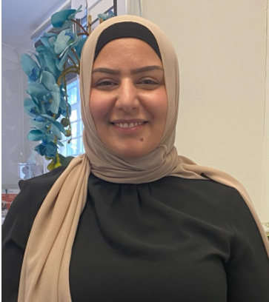

Mr Melvin Katoa – Wellbeing Support Officer working Wednesday and Friday.
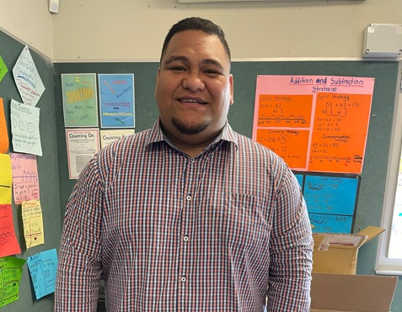

Mrs Fatma Hawat – School Learning and Support Officer working Wednesday – Friday.

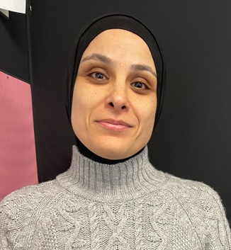

Miss Mariam – School Learning and Support Officer working on a Thursday.

Over the last 6 months we have been collecting and analysing data in order to write our 2021 – 2024 Strategic Improvement Plan. I am excited to say that our plan is now complete and available on our school website (about our school / school planning and reporting / 2021 – 2024 Strategic Improvement Plan).
Our three strategic directions are,
1. Student growth and attainment - improving student growth in reading and numeracy.
2. Effective Classroom Practice – focusing on collaboration and student assessment.
3. Student Wellbeing and Engagement - creating a school culture that fosters a sense of belonging for all students, staff and community.
We will be working hard over the next four years to ensure we meet all set targets.
To all our families celebrating EID in a few weeks, I wish you and your family joy, happiness, peace, prosperity and lots of love. Eid Mubarak!

Kind regards,
Karen Macphail

Upcoming Events

Week 2
Thursday 29/4 Kindergarten Farm excursion
Whole school assembly at
2:10pm
Friday 30/4 PSSA begins
Week 3
Monday 3/4 Sydney Writer’s Festival
Wednesday 5/4 Year 1 & 2 Excursion
Thursday 6/5 Mother’s Day Stall
P&C meeting at 9:10am
Friday 7/5 PSSA
Week 4
Monday 10/5 Stage 2 & 3 Multicultural
Speaking competition
Tuesday 11/5 NAPLAN (if EID falls on the
Wednesday)
Wednesday 12/5 EID celebrations
Thursday 13/5 Whole school assembly at
2:10pm
Friday 14/5 PSSA

It's not OK to stay away!

The thought of an argument with children to get them to school is too great to bear for some parents. Too many students miss school through parent-condoned absences. Every day a student is away they are missing a learning experience.

If a child misses school for around 1 day a week, by the end of the year they will have missed almost 1 whole term of school. Over the primary school years they would miss almost 3 years of school.
What is a Justified Absence from school?

- For an unavoidable medical or dental appointment. (best made for after school or in the holidays).
- To attend a recognised religious holiday.
- To attend an exceptional or urgent family circumstance (e.g. a funeral).
- While sick or with an infectious disease.

If you require support to get your child to attend school or if you have any questions please do not hesitate to contact the school.

We can all work together to make a difference to your child's future!

Winter Uniform (Term 2 and Term 3)

Please ensure your child is wearing the correct uniform and that their items are clearly labelled with their names and current class on it.

Girls
- Blue / white school shirt with school crest on the pocket
- Long blue pants (not tracksuit pants)
- Blue/white fleecy bomber jacket (school crest) or blue zip up jacket (school crest)
- White socks (no tennis/low sports socks)
- Black shoes
- Navy blue stockings can be worn under skorts/dress
Boys
- Blue / white shirt with school crest on the pocket
- Long grey pants (not tracksuit pants)
- Blue/white fleecy bomber jacket (school crest) or blue zip up jacket (school crest)
- Grey socks (no tennis/low sports socks)
- Black shoes

Sports Uniform Girls and Boys

- Granville South PS sports shirt (blue and yellow) and blue sports shorts (with school initials)
- White socks (no tennis/low sports socks) and predominantly white joggers with white laces
- Long blue sports pants or blue tracksuit pants
- Blue fleecy bomber jacket (school crest) or blue zip up jacket (school crest)

Survey - Before and after school care

Does your child need before and after school care? We want to hear from you – please complete a short survey to help us understand your family’s needs for care out of school hours. Your responses will shape what we do to expand and deliver Before and After School Care services in your community and across NSW.

Please complete the survey via the following website link: https://surveys.education.nsw.gov.au/s3/OSHCParentsSurvey. The survey will be open until 24 May 2021.

The survey has been designed to be easy to use and should take no more than two minutes to complete, with a few extra minutes for those who would like to supply additional information.
If you need a paper or over-the-phone version of the survey, or require a survey translation, please contact the Department of Education Before and After School Care Program team by phone on 1300 244 145 or email at: BASCReform@det.nsw.edu.au.

Student Safety

The school traffic on Woodville Road / Oxford Street and Highland Street is constantly growing as is the school. I would appreciate all parents be vigilant whether you are in your car driving or walking with your child.

- Please be aware that there is an increased chance of young children emerging between cars during the busy peak drop off and pick up times for our school. Their size and unpredictable behaviour makes it more difficult for drivers to see them.
- When parents are dropping off or picking up children at inappropriate locations drivers place all children in the vicinity, including their own, at risk.
- Parking restrictions around schools are specifically designed to improve the safety of pedestrians, and minimise traffic congestion.
- Fines and penalties apply for failure to comply with road laws. Police regularly patrol our school zones.

Check-in assessment for Years 4 and 6

This week students from Years 4 and 6 participated in a reading and numeracy check-in assessment.
The check-in assessment is a NSW Department of Education online reading and numeracy assessment available to support schools to assess and monitor student learning following the period of learning from home.

The check-in assessments can supplement existing school practices to identify how students are performing in literacy and numeracy and to help teachers tailor their teaching more specifically to student needs.

Year 5 Opportunity Class Placement - 2022

The application process for Year 5 opportunity class placement for entry in 2022 is about to begin, with online applications opening tomorrow. We would like to remind you that all Intention to Apply forms must be returned to the class teacher tomorrow, as they are an indication to the school that you intend to register your child for the test.

Parents and carers must apply online between Tuesday 20 April and Friday 7 May 2021 at: https://education.nsw.gov.au/public-schools/selective-high-schools-and-opportunity-classes/year-5

NAPLAN – Yrs 3 & 5

In May 2021 the National Assessment Program - Literacy and Numeracy (NAPLAN) will be completed by students in Years 3, 5, 7 and 9. NAPLAN has the support of all State and Territory Education Ministers and will assess the literacy and numeracy skills of students across Australian schools.

The results of the tests will provide important information to schools about what each student can do, and will be used to support teaching and learning programs. Parents will receive a report indicating their child's level of achievement. Each student's level of achievement will be reported against the national minimum standard.

Student background information (student name, gender, date of birth, language background and Aboriginality) will be collected as part of the National Assessment Program. This information is treated confidentially and held securely to ensure that every student's right to privacy is maintained.

In 2021, your child will sit the NAPLAN online tests. However, children in some other schools across Australia will sit the NAPLAN paper tests this year. Federal, state and territory education ministers have agreed that all schools will move online by 2020. State and territory education authorities will determine when their schools move online.

As students are assessed on the same literacy and numeracy curriculum content, regardless of whether they complete the test online or on paper, results for both formats can be reported on the same NAPLAN assessment scale. To find out more about NAPLAN Online, visit nap.edu.au

This year students in Years 3 & 5 will be sitting the NAPLAN test starting Tuesday 11th May. We understand that for the majority of our students this is during the same time as EID celebrations. The Department of Education and NESA are aware of this and has allowed us some flexibility to ensure that students who celebrate EID will not miss out on sitting NAPLAN. Therefore, we will be doing the following:
- If EID falls on Tuesday 11th May, the writing test for all students will be on Friday 14th May (this test will be done in the morning so it will not impact on students attending PSSA).
- If EID falls on Wednesday 12th May, the writing test for all students will remain on Tuesday 11th May.

I will be informing students / parents closer to the date of the exact date of the writing test so that the children are aware of what is happening.

Birthdays

We love sharing in birthday celebrations with our students. If you wish, you may send in store bought cupcakes only. Balloons, lolly bags etc will be sent back home. The cupcakes and celebration will be for class members only. Parents, siblings or cousins will need to celebrate at home with the child.

Thank you for your cooperation with this.

Canteen

A reminder that canteen orders need to be in by 3:15pm each Monday in order to receive the lunch order on Tuesday.

K-2 Gymnastics

We have been very fortunate once again to receive a small amount of funding through the Federal Governments Sporting Schools program. This term the money is enabling all K-2 students to participate in a gymnastics program that started this week. The program will be run by qualified instructors from Be Skilled Be Fit.

Lost Property

Unfortunately our lost property pile is growing on a daily basis. I know you share my frustration in seeing piles of new clothing that children have misplaced. If your child has lost an item of clothing then please come up to the veranda outside the school office to collect it. Any unlabelled items not taken within two weeks will be put into our second hand clothing pile.

P&C AGM
Our Annual General Meeting (AGM) for the P&C will be held on Thursday 6th May at 9:10am, followed by our April meeting at 9:30am.
At the AGM all positions are made vacant and nominations are sought for all formal roles. This includes:
- Office Bearer positions of President, Vice Presidents (two), Treasurer, Secretary, Assistant Treasurer and Assistant Secretary.
You need to already be a financial member to nominate for a role at the AGM. If not, you can pay your $1 membership before the end of the AGM and you can nominate for vacant roles in the March meeting (immediately after the AGM at 9:30am, March 25).
We are always looking for more members to join our P&C, have their say and contribute to our community.

Tasneem A | 4/3N | 1st Shining Star
Megan M | 4/3N | 2nd Shining Star
Frashta M | 4/3N | 3rd Shining Star
Daro H | 4/3N | 3rd Shining Star
Lucas T | 4/3N | 1st Shooting Star
Whareth E | 4/3N | 1st Shooting Star
Mackenzie G | 4/3N | 2nd Shooting Star
Artin N | 4/3N | 1st Super Star
Muriel S | 4/3N | 3rd Shining Star
Moustafa El | 1PD | 2nd Shining Star
Setayesh A | 1/KM | 3rd Shining Star
Lucas | 4/3N | 3rd Shining Star
Noura M | 4/3N | 2nd Shooting Star
Marwa I | 4/3E | 1st Super Star
Zeyan D | 3/2S | 2nd Shooting Star
Jayden C | 3/2S | 2nd Shooting Star
Joshua S | 3/2S | 2nd Shooting Star
Blaine D | 3/2S | 3rd Shining Star
Roqaya A | 3/2S | 3rd Shining Star
Kiana A | 2S | 3rd Shining Star
Hanan A | 6/5H | 3rd Shining Star
Naazanin K | 1/KM | 1st Shining Star
Roqaya A | 3/2S | 3rd Shining Star
Blaine D | 3/2S | 3rd Shining Star
Isaac A | 3/2S | 3rd Shining Star
Moussa T | 3/2S | 2nd Shooting Star
Alana A | 4/3T | 1st Super Star
Taqi | 4/3T | 2nd Shooting Star
Savannah G | 4/3T | 3rd Shooting Star
Around the grounds

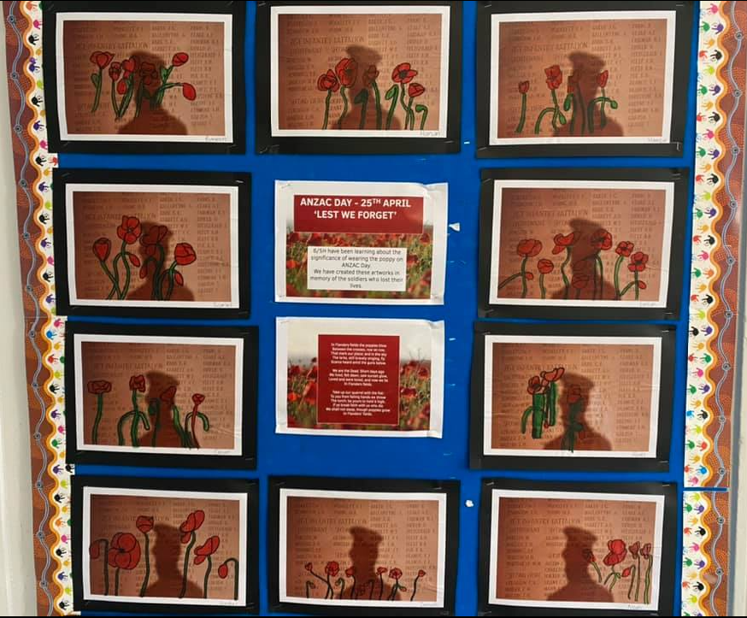

ANZAC Day artwork and assembly

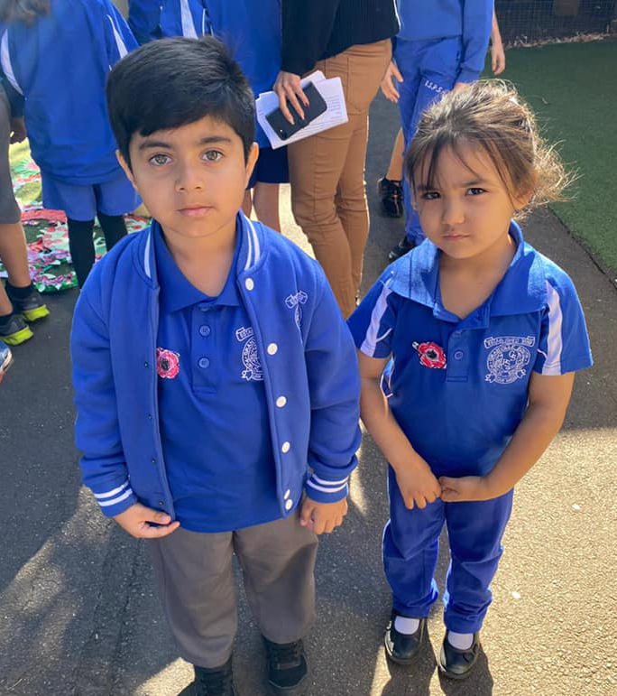

PBL Awards

Around the grounds

Breakfast club

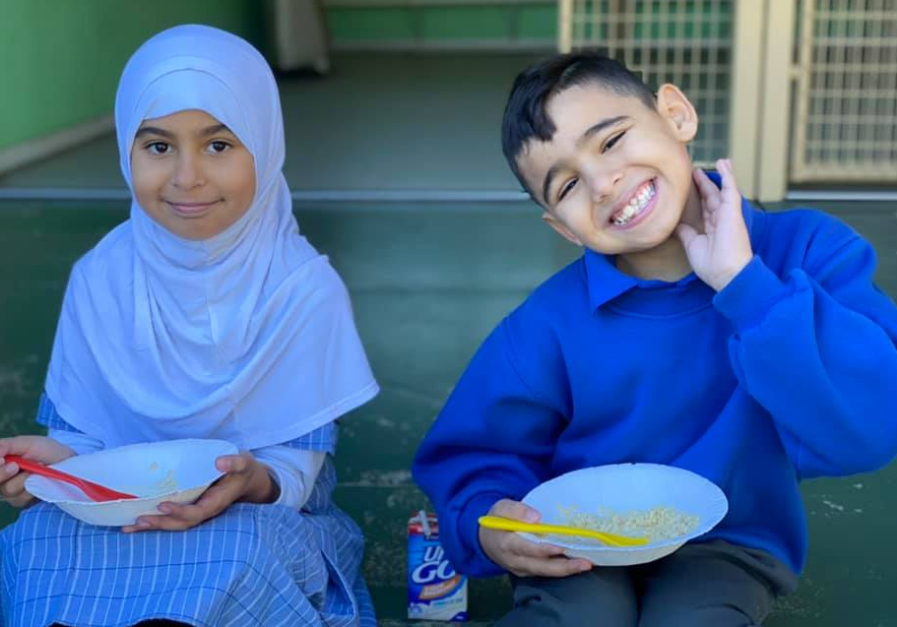

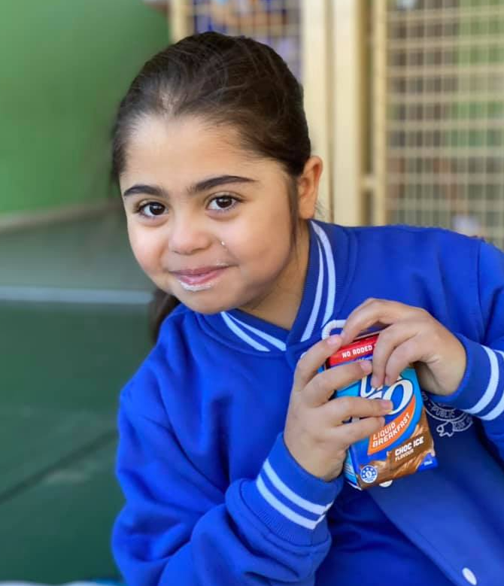

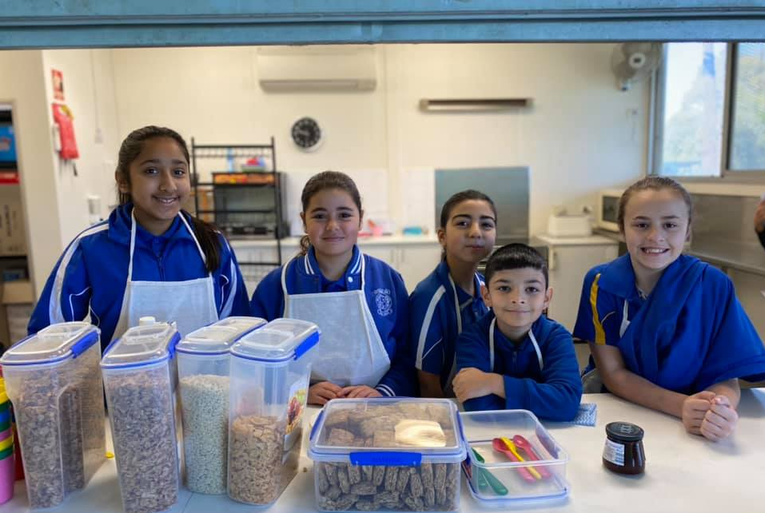

Yusuf H playing in the Auburn Zone Representative Team – Congratulations Yusuf.

